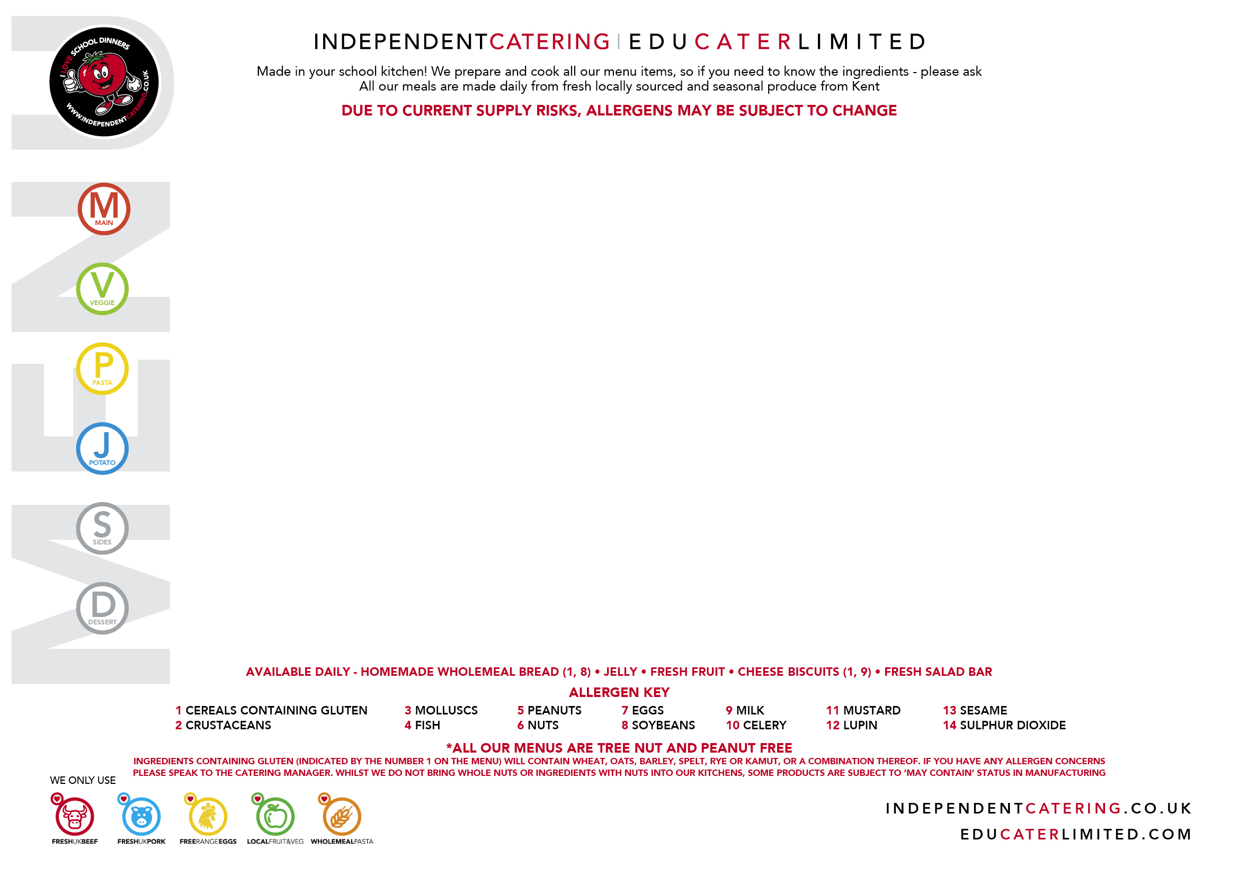

MONDAY 23 FEBRUARY | TUESDAY 24 FEBRUARY | WEDNESDAY 25 FEBRUARY | THURSDAY 26 FEBRUARY | FRIDAY 27 FEBRUARY
Chicken Nuggets  (‘Sweet and Sour’  Sauce on the Side)  (1, 8, 10, 14) | Beef Lasagne with  Garlic Bread  (1, 7, 8, 9, 11)  (May Contain 10) | Roast Gammon  and Pineapple  with Gravy |   Chicken and Vegetable Rice (Jambalaya)  (1,10)  Traditional Bean Stew (Mardi Gras Bean Gumbo) with Crusty Bread  (1,8,10) VEGAN  Mac n’ Cheese  (1, 9, 11)  [May Contain 8]  Jacket Potato with Choice of Topping  Mini Corn on the Cob  Banana Foster Cheesecake  (1, 9)  (May Contain 8) | Breaded Fish  (1, 4)
Quorn Dippers  (‘Sweet and Sour’  Sauce on the Side)  (1, 8, 10, 14)  VEGAN | Vegetable Lasagne with  Garlic Bread  (1, 7, 8, 9, 11)  (May Contain 10) | Cheese and  Roast Vegetable Quiche  (1, 7, 9)  (May Contain 10) |  | Homemade  Chickpea Burger in a Bun  (1)  (May Contain 13)  VEGAN
Chunky Tomato Pasta  (1)  (May Contain 10) | Vegetable Ragu Twirls  (1)  (May Contain 10) | Mixed Pepper Pasta  (1)  (May Contain 10) |  | Arrabiata Pasta Twirls  (1)  (May Contain 10)
Jacket Potato with  Topping of the Day | Jacket Potato with  Topping of the Day | Jacket Potato with  Topping of the Day |  | Jacket Potato with  Topping of the Day
Savoury Rice with  Garden Peas  and Salad Bar | Fresh Carrots  and Salad Bar | Roast Potatoes, Roasted Vegetables and Green Beans  Try our Vegetable of the month  (10) |  | Chips, Baked Beans  and Salad Bar
Oaty Apple Crumble  with Custard  (1, 9)  (May Contain 8) | Tutti Frutti Tuesday | Raspberry Ripple Sponge  with Custard  (1, 7, 9)  (May Contain 8) |  | Chocolate Krispie  (1, 9)
THE CHURCHILL PRIMARY SCHOOL
WEEK
1

MONDAY 2 MARCH | TUESDAY 3 MARCH | WEDNESDAY 4 MARCH | THURSDAY 5 MARCH | FRIDAY 6 MARCH
Beef Spaghetti Bolognaise  and Garlic Bread  (1, 8)  (May Contain 10) | Chicken Wrap served with BBQ Sauce  (1, 8)  (May Contain 9, 10, 11) | Roast Beef with a  Yorkshire Pudding and Gravy  (1, 7, 9) | Fajita Chicken Taco with Rice  (11)  (May Contain 10) | Sausage with a Bun  (with Ketchup on the Side)  (1, 14)  (May Contain 13)
Lentil and Bean Spaghetti Bolognaise and Garlic Bread  (1, 8)  (May Contain 10)  VEGAN | Roast Vegetable & Bean Wrap  (1, 11)  (May Contain 10)  VEGAN | Winter Vegetables  served in a Yorkshire Pudding  (1, 7, 9)  (May Contain 10) | Veggie Mince Taco with Rice  (8,11)  (May Contain 10) | Vegetable Sausage with a Bun  (with Ketchup on the Side)  (1)  (May Contain 13)  VEGAN
Chunky Tomato Twirls  (1)  (May Contain 10) | Mac n’ Cheese  (1, 9, 11)  (May Contain 8) | Tomato and Basil Pasta  (1)  (May Contain 10) | Fresh Pesto Pasta  (1)  (May Contain 10) | Mixed Vegetable  Ragu Twirls  (1)  (May Contain 10)
Jacket Potato with  Topping of the Day | Jacket Potato with  Topping of the Day | Jacket Potato with  Topping of the Day | Jacket Potato with  Topping of the Day | Jacket Potato with  Topping of the Day
Fresh Broccoli  and Salad Bar | Herby Potatoes,  (May Contain 10)  Garden Peas  and Salad Bar | Roast Potatoes, Fresh Carrots  and Cabbage  Try our Vegetable of the month  (10) | Sweetcorn and Peas  and Salad Bar | Chips, Garden Peas  and Salad Bar
Steamed Apple and Pear Sponge with Custard  (1, 7, 9)  (May Contain 8) | Tutti Frutti Tuesday | Toffee Sponge  and Custard  (1, 7, 9, 14)  (May Contain 8) | Chocolate and Orange Brownie (1, 7)  (May Contain 8) | Oat Cookie  (1)  (May Contain 8)
THE CHURCHILL PRIMARY SCHOOL

WEEK
2
MONDAY 9 MARCH | TUESDAY 10 MARCH | WEDNESDAY 11 MARCH | THURSDAY 12 MARCH | FRIDAY 13 MARCH
Mild Chicken Curry  with Rice and Naan Bread  (1)  (May Contain 10, 11) | Beef Nachos  (9)  (May Contain 1, 10, 11) | Roast Turkey  with Stuffing and Gravy  (1) | Homemade Sausage Roll  (1, 8, 9,14) | Fishfingers  (1, 4)  or Salmon Fishcake  (1, 4)
Chickpea Korma  with Rice and Naan Bread  (1)  (May Contain 10, 11)  VEGAN | Mixed Bean Chilli in a Taco with Tomato Rice  (May Contain 10)  VEGAN | Roasted Tomato, Carrot  and Lentil Loaf  (7)  (May Contain 10) | Cheese, Potato  and Leek Turnover  (1, 9) | Pesto Halloumi and Roasted Vegetables with Pitta Bread  (1, 9)  (May Contain 10)
Mac n’ Cheese  (1, 9, 11)  (May Contain 8) | Roasted Vegetable  Pasta Bows  (1)  (May Contain 10) | Mixed Pepper Pasta  (1)  (May Contain 10) | Fresh Pesto Pasta  (1)  (May Contain 10) | Tomato Sauce served with Pasta Bows  (1)  (May Contain 10)
Jacket Potato with  Topping of the Day | Jacket Potato with  Choice of Toppings | Jacket Potato with  Topping of the Day | Jacket Potato with  Topping of the Day | Jacket Potato with  Topping of the Day
Sweetcorn  and Salad Bar | Green Beans, Tomato Salsa  and Salad Bar | Roast Potatoes, Roasted Vegetables and Peas  Try our Vegetable of the month  (10) | Broccoli, Herby Potatoes  (May Contain 10)  and Salad Bar | Chips, Baked Beans  and Salad Bar
Caramelised Pear and  Apple Cake with Custard  (1, 7, 9)  (May Contain 8) | Iced Carrot Cake  (1, 7, 9)  (May Contain 8) | Chocolate Sponge and Chocolate Sauce  (1, 7, 9)  (May Contain 8) | Tutti Frutti Thursday | Oaty Cherry Cookie  (1, 14)  (May Contain 8)
WEEK
3
THE CHURCHILL PRIMARY SCHOOL

MONDAY 16 MARCH | TUESDAY 17 MARCH | WEDNESDAY 18 MARCH | THURSDAY 19 MARCH | FRIDAY 20 MARCH
Chicken Nuggets  (‘Katsu’ Sauce on the Side)  (1, 8, 10) |   Lemon Chicken and Steamed Rice  (Frango Grelhado com Limão with Arroz Branco)  (8, 11)  (May Contain 10)  Brazilian Vegetable Stew  (Moqueca de Legumes Vegan)  (May Contain 10)  Tomato Pasta  (Maccarronada)  (1)  (May Contain 10)  Jacket Potato with Choice of Topping  Sautéed Greens with Carrot (Couve Refogada)  Banana Sponge Cake  (Bolo de Banana)  (1,7)  (May Contain 8) | Roast Gammon  and Pineapple  with Gravy | Meat Feast Pizza  (1, 8, 9)  (May Contain 7,10) | Breaded Fish  (1, 4)
Katsu Quorn Dippers  (‘Katsu’ Sauce on the Side)  (1, 8)  VEGAN |  | Cheese and  Roast Vegetable Quiche  (1, 7, 9)  (May Contain 10) | Cheese and  Tomato Pizza  (1, 8, 9)  (May Contain 7,10) | Homemade  Chickpea Burger in a Bun  (1)  (May Contain 13)  VEGAN
Chunky Tomato Pasta  (1)  (May Contain 10) |  | Mixed Pepper Pasta  (1)  (May Contain 10) | Fresh Pesto Pasta  (1)  (May Contain 10) | Arrabiata Pasta Twirls  (1)  (May Contain 10)
Jacket Potato with  Topping of the Day |  | Jacket Potato with  Topping of the Day | Jacket Potato with  Topping of the Day | Jacket Potato with  Topping of the Day
Savoury Rice with  Garden Peas  and Salad Bar |  | Roast Potatoes, Roasted Vegetables and Green Beans Try our Vegetable of the month  (May Contain 10) | Baked Beans, Diced Potatoes  and Salad Bar | Chips, Garden Peas  and Salad Bar
Oaty Apple Crumble  with Custard  (1, 9)  (May Contain 8) |  | Raspberry Ripple Sponge  with Custard  (1, 7, 9)  (May Contain 8) | Tutti Frutti Thursday | Chocolate Krispie  (1, 9)
WEEK
4
THE CHURCHILL PRIMARY SCHOOL

MONDAY 23 MARCH | TUESDAY 24 MARCH | WEDNESDAY 25 MARCH | THURSDAY 26 MARCH | FRIDAY 27 MARCH
Beef Spaghetti Bolognaise  and Garlic Bread  (1, 8)  (May Contain 10) | Chicken Wrap served  with BBQ sauce  (1, 8)  (May Contain 9, 10, 11) | Roast Beef with a  Yorkshire Pudding and Gravy  (1, 7, 9) | Fajita Chicken Taco with Rice  (11)  (May Contain 10) | Sausage with a Bun  (with Ketchup on the Side)  (1, 14)  (May Contain 13)
Lentil and Bean Spaghetti Bolognaise and Garlic Bread  (1, 8)  (May Contain 10)  VEGAN | Roast Vegetable & Bean Wrap  (1, 11)  (May Contain 10)  VEGAN | Winter Vegetables  Served in a Yorkshire Pudding  (1, 7, 9)  (May Contain 10) | Veggie Mince Taco with Rice  (8,11)  (May Contain 10) | Vegetable Sausage with a Bun  (with Ketchup on the Side)  (1)  (May Contain 13)  VEGAN
Chunky Tomato Twirls  (1)  (May Contain 10) | Mixed Pepper Pasta  (1)  (May Contain 10) | Tomato and Basil Pasta  (1)  (May Contain 10) | Mac n’ Cheese  (1, 9, 11)  (May Contain 8) | Mixed Vegetable  Ragu Twirls  (1)  (May Contain 10)
Jacket Potato with  Topping of the Day | Jacket Potato with  Topping of the Day | Jacket Potato with  Topping of the Day | Jacket Potato with  Topping of the Day | Jacket Potato with  Topping of the Day
Fresh Broccoli  and Salad Bar | Herby Potatoes,  (May Contain 10)  Garden Peas  and Salad Bar | Roast Potatoes, Fresh Carrots  and Cabbage  Try our Vegetable of the month  (May Contain 10) | Sweetcorn and Peas  and Salad Bar | Chips, Baked Beans  and Salad Bar
Steamed Apple and Pear Sponge with Custard  (1, 7, 9)  (May Contain 8) | Tutti Frutti Tuesday | Toffee Sponge  and Custard  (1, 7, 9, 14)  (May Contain 8) | Chocolate and Orange Brownie (1, 7)  (May Contain 8) | Oat Cookie  (1)  (May Contain 8)
WEEK
5

THE CHURCHILL PRIMARY SCHOOL

MONDAY 30 MARCH | TUESDAY 31 MARCH | WEDNESDAY 1 APRIL | THURSDAY 2 APRIL | FRIDAY 3 APRIL
Mild Chicken Curry  with Rice and Naan Bread  (1)  (May Contain 10, 11) | Beef Nachos  (9)  (May Contain 1, 10, 11) | Roast Turkey  with Stuffing and Gravy  (1) | Fishfingers  (1, 4)  or Salmon Fishcake  (1, 4) | Good Friday
Chickpea Korma  with Rice and Naan Bread  (1)  (May Contain 10, 11)  VEGAN | Mixed Bean Chilli in a Taco with Tomato Rice  (May Contain 10)  VEGAN | Roasted Tomato, Carrot  and Lentil Loaf  (7)  (May Contain 10) | Pesto Halloumi and Roasted Vegetables with Pitta Bread  (1, 9)  (May Contain 10) | Good Friday
Mac n’ Cheese  (1, 9, 11)  (May Contain 8) | Roasted Vegetable  Pasta Bows  (1)  (May Contain 10) | Mixed Pepper Pasta  (1)  (May Contain 10) | Tomato Sauce served with Pasta Bows  (1)  (May Contain 10) | Good Friday
Jacket Potato with  Topping of the Day | Jacket Potato with  Choice of Toppings | Jacket Potato with  Topping of the Day | Jacket Potato with  Topping of the Day | Good Friday
Sweetcorn  and Salad Bar | Green Beans, Tomato Salsa and Salad Bar | Roast Potatoes, Roasted Vegetables and Peas  Try our Vegetable of the month  (May Contain 10) | Chips, Baked Beans  and Salad Bar | Good Friday
Caramelised Pear and  Apple Cake with Custard  (1, 7, 9)  (May Contain 8) | Iced Carrot Cake  (1, 7, 9)  (May Contain 8) | Chocolate Sponge and Chocolate Sauce  (1, 7, 9)  (May Contain 8) | Easter Cookies & Cakes  (1, 7,9,14)  (May Contain 8) | Good Friday
WEEK
6

THE CHURCHILL PRIMARY SCHOOL

